Single Inheritance

Program:

Output:



Multilevel Inheritance

Program:

Output:



Hierarchical Inheritance

Program:

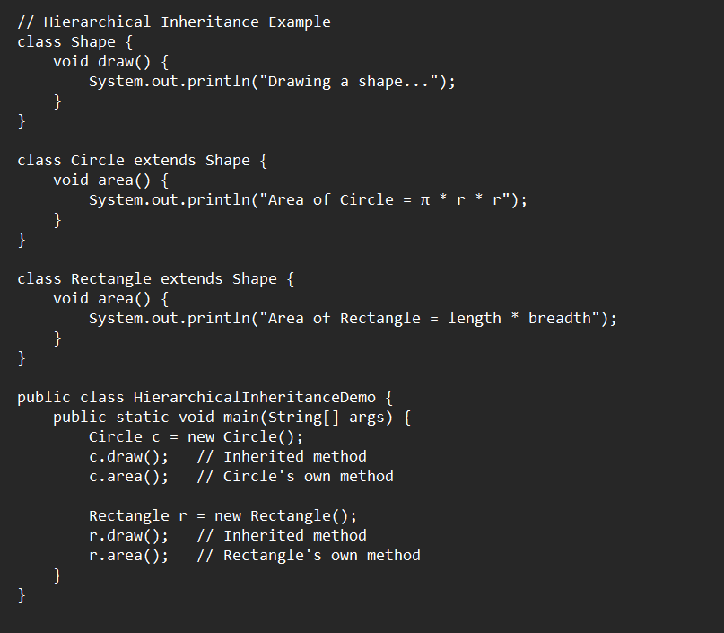

Output:

